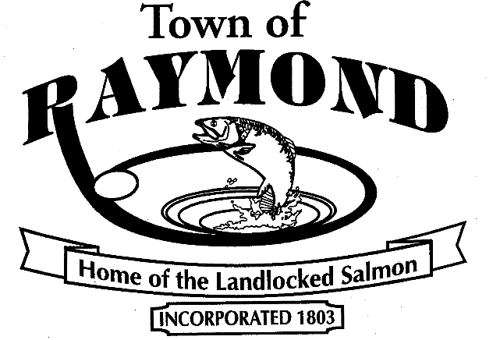 | SELECT BOARD  Minutes  June 19, 2018  6:30pm – Regular Meeting  Broadcast Studio  423 Webbs Mills Road
Resolution: We, the Raymond Board of Selectmen, recognize our individual and collective responsibilities as leaders and representatives of our community. To this end, we pledge to conduct ourselves in a manner befitting these roles and duties. We pledge and encourage others to “Be the Influence” and to recognize that decisions matter.

Excerpt of June 19, 2018 Minutes:

- New Business
  - RSU Withdrawal Update Presentation – Teresa Sadak, Chair of Select Board
Chair Teresa Sadak presented the latest information regarding the ongoing petition and related efforts to withdraw from RSU #14. She needed 235 valid signatures and collected 353 valid signatures.
Chair Sadak – One of the key issues is getting information out to folks. This isn’t something we have rushed into. We have worked as a Select Board sending letters and have had the Town Attorney send letters to the RSU Board and the Town of Windham to come to the table and talk to us. We are having our hand forced right now. This is a 22-step process. There is a lot of work that has to be done.
Selectman Olsen – I think it is important for people to understand that this is only a first step to allow the process to start. This is not a document that withdraws us from the RSU at this point.
Chair Sadak – I started this 3 years ago and it was not unsuccessful. We got a cost sharing agreement that reduced the percentage of Raymond’s share. What we are not successful in right now is the (RSU) Board adhering to that cost sharing agreement. I am looking to work with a consultant who has done this before.
Motion to accept the petition as presented by Selectman Olsen. Seconded by Selectman Taylor.
Unanimously approved.
Motion to set the date of the Public Hearing as July 31st and the Special Town Meeting on August 14th by Selectman Olsen. Seconded by Selectman Taylor.
Unanimously approved.

I attest that this is a true copy.

Susan L Look, Town Clerk

