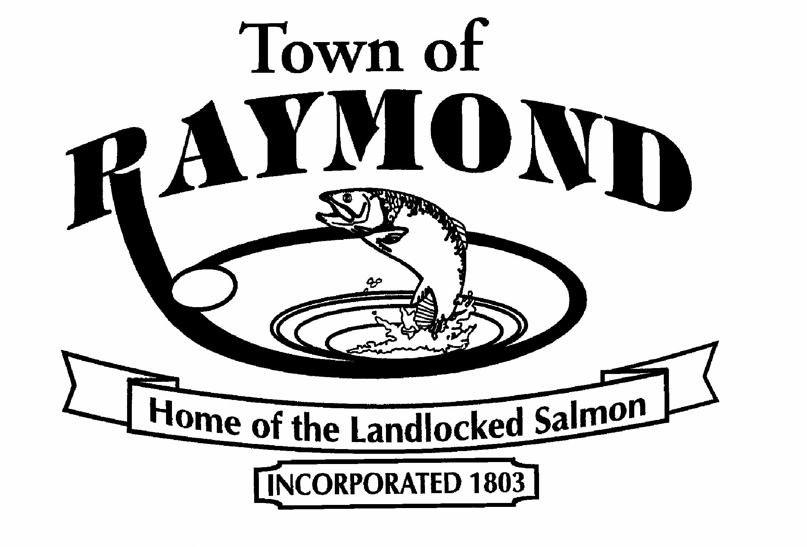 | The Town of Raymond Needs Volunteers  To Serve on Various Boards and Committees
If you are a Raymond resident and interested in serving on any of the following committees or boards, please fill in the information below and return it to the Town Clerk, who will make sure it gets to the appropriate board or committee chair(s) for consideration and response. Not all committees and boards currently have openings, however, vacancies occur on a regular basis.

- Beautification Committee
- Board of Assessment Review
- Cemetery Committee
- Conservation Commission
- Planning Board
- Raymond Recreation Association
- Recycling Committee
- Tassel Top Park Board of Directors
- Technology Committee
- Veteran’s Memorial Committee
- Zoning Board of Appeals

There are many other opportunities to serve your town as an elected official, a member of a community resource organization, an election worker on Election Day, etc. Contact the Town Clerk for more information.
Please complete this form and submit to:
Town Clerk, 401 Webbs Mills Road, Raymond ME 04071
or via fax to (207) 655-3024
or via email to sue.look@raymondmaine.org
Name:
Mailing Address:
Telephone Number:
Occupation:
E-mail Address:

Boards and/or committees you are interested in (please list in order of preference):
1.
2.
3.

Why are you interested in the board(s) and/or committee(s) chosen above?

What contributions, benefits, talents, and skills can you bring to the Town of Raymond?

What do you feel is the responsibility of the boards and/or committees you chose?

What municipal boards, volunteer organizations, or community service groups/committees have you worked with in the past and for what length of time?

Will your schedule be flexible enough to allow you to attend meetings on a regular basis?
Yes _________ No _________

Thank you for your interest in the Town of Raymond!

