DISASTER NEWS
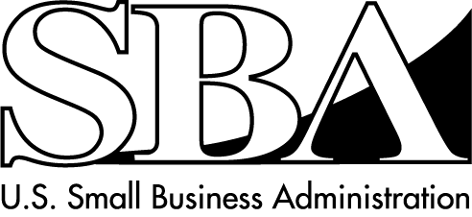
Economic Injury Loans for Small Businesses
SBA Disaster Assistance – Field Operations Center- East – 101 Marietta Street, NW, Suite 700, Atlanta, GA 30303 Release Date: Sept. 8, 2016 Contact: Michael Lampton
Release Number: 16-534, ME 14845 Email: Michael.Lampton@sba.gov
Phone: (404) 331-0333

SBA Economic Injury Disaster Loans Available in Maine
for Small Businesses Impacted by July Drought

ATLANTA - The U.S. Small Business Administration (SBA) announced today that federal Economic Injury Disaster Loans are available to small businesses, small agricultural cooperatives, small businesses engaged in aquaculture and private nonprofit organizations in Maine as a result of the drought that began on
July 5, 2016.

This disaster declaration includes the following counties: Cumberland, Oxford and York counties located in Maine.

“When the Secretary of Agriculture issues a disaster declaration to help farmers recover from damages and losses to crops, the Small Business Administration issues a declaration to eligible entities affected by the same disaster,” said Frank Skaggs, director of SBA’s Field Operations Center East in Atlanta.

Under this declaration, the SBA’s Economic Injury Disaster Loan program is available to eligible
farm-related and nonfarm-related entities that suffered financial losses as a direct result of this disaster. With the exception of aquaculture enterprises, SBA cannot provide disaster loans to agricultural producers, farmers, or ranchers. Nurseries are eligible to apply for economic injury disaster loans for losses caused by drought conditions.

The loan amount can be up to $2 million with interest rates of 2.625 percent for private nonprofit organizations and 4 percent for small businesses, with terms up to 30 years. The SBA determines eligibility based on the size of the applicant, type of activity and its financial resources. Loan amounts and terms are set by the SBA and are based on each applicant’s financial condition. These working capital loans may be used to pay fixed debts, payroll, accounts payable, and other bills that could have been paid had the disaster not occurred. The loans are not intended to replace lost sales or profits.

Applicants may apply online using the Electronic Loan Application (ELA) via SBA’s secure website at https://disasterloan.sba.gov/ela.

Disaster loan information and application forms may also be obtained by calling the SBA’s Customer Service Center at 800-659-2955 (800-877-8339 for the deaf and hard-of-hearing) or by sending an email to disastercustomerservice@sba.gov. Loan applications can be downloaded from the SBA’s website at www.sba.gov/disaster. Completed applications should be mailed to: U.S. Small Business Administration, Processing and Disbursement Center, 14925 Kingsport Road, Fort Worth, TX 76155.

Completed loan applications must be returned to SBA no later than May 1, 2017.

# # #

For more information about the SBA’s Disaster Loan Program, visit our website at www.sba.gov/disaster.

