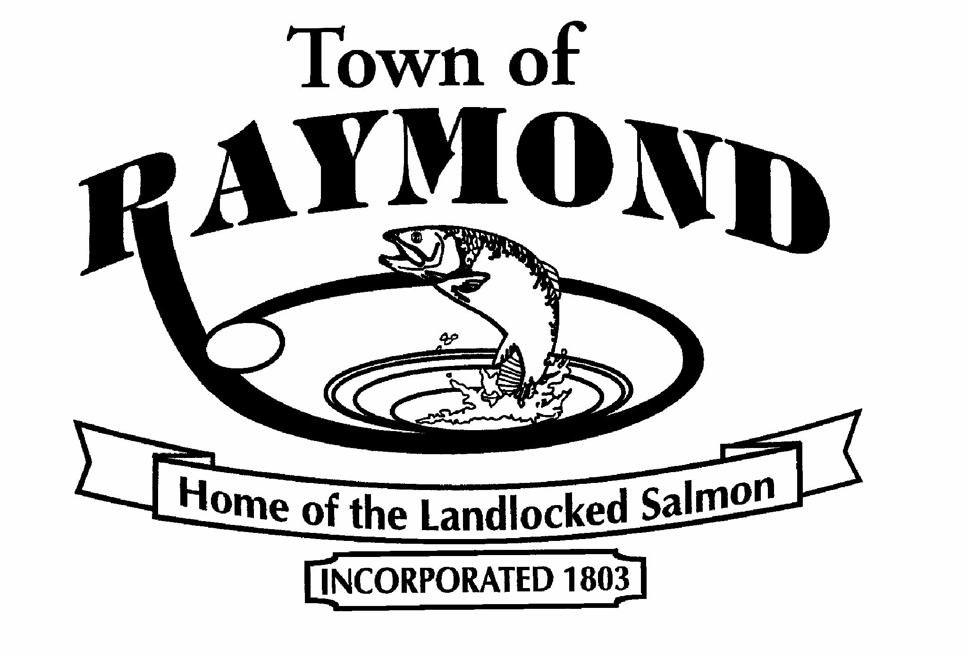

TOWN OF RAYMOND, MAINE

Public Works Mechanic

The Town of Raymond is seeking a full time Mechanic to join our Public Works Department. The position is responsible for the maintenance, diagnosis and repair of all Town Public Works vehicles and equipment including heavy and light trailers, heavy construction equipment and fire apparatus. The selected candidate will work under the supervision of the Public Works Director.

The Mechanic will maintain and repair engines, transmissions, hydraulic systems, electrical systems, air brakes, and plow gear along with other equipment. The successful candidate must be able to keep accurate records and document work performed. The candidate must have the ability to inspect Public Works vehicles and equipment as required by Maine State Vehicle Inspection. The Mechanic must be available to work during adverse weather events and any other emergency situations.

Graduation from high school or GED and a valid State of Maine Class B commercial driver’s license and State of Maine Motor Vehicle Inspection license to include A, D, and E classifications are required. Experience a plus. The Mechanic must possess their own tools to adequately perform work on the Public Works Fleet.

The Town of Raymond offers competitive pay and benefits including medical and dental insurance and a 457 Deferred Compensation Plan. Applications are available on the website at www.raymondmaine.org or at the Raymond Town Office, 401 Webbs Mills Road, Raymond, Maine 04071. Cover letter, application and resume should be sent to:

Rita Theriault
Human Resource Officer
Town of Raymond
401 Webbs Mills Road
Raymond, Maine 04071
Application deadline is Tuesday, July 3, 2018 by 4:00 PM.
The Town of Raymond is an Equal Opportunity Employer.

