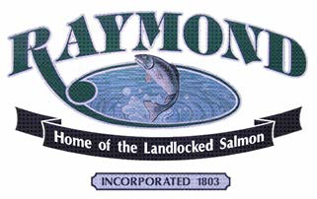

The Town of Raymond, Maine is seeking a creative, proactive, community leader to serve as its next Town Manager.

The Town of Raymond is a small community in the heart of the Lakes Region within the larger, growing region of Southern Maine. We take pride in the natural beauty that surrounds us. Our identity as a place of peaceful respite from the more hectic energy of the larger centers within the region can only be maintained by dutifully stewarding the local and regional natural resources of Sebago Lake, Panther Pond, Crescent Lake, Raymond Pond, Thomas Pond, Raymond Community Forest, Morgan Meadows, Pismire Mountain, Nubble Pond, and Notched Pond. As a rural town within driving distance of Portland, we place priority and value on the features that set us apart: our beautiful environment and a quiet, small-town community with convenient access to nearby economic centers. Population is 4,536 as of the 2020 census, rising to close to 12,000 in July and August.

The Town Manager reports to a five-member Select Board. Like many towns in Maine, it is a Town Meeting form of government. The annual Town operating budget is $9.5M, excluding schools. The Town employs 35 full-time and approximately 65 part-time and seasonal staff.

The successful candidate will have strong experience in local government operations, personnel management, labor relations, and community-based problem solving. Strong interpersonal, listening, written, and verbal skills required.

The Town of Raymond requires a bachelor’s degree in a related field, 5-10 years of progressive experience in municipal government, or an equivalent combination of education and experience. Special consideration will be given to applicants with a master’s degree in public administration. The Town offers a generous benefit package along with a salary commensurate with qualifications and experience.

A complete job description can be found on the Town of Raymond’s website.
Interested candidates who have a passion for serving local government and its citizens are invited to submit a letter of interest, resume, and three letters of reference in confidence to:
betsy@hrmaineconsulting.com
or via mail to:
Betsy Oulton
HR Maine Consulting, LLC
2 Country Lane
Falmouth, ME 04105
This position remains open until April 30, 2025
The Town of Raymond is an Equal Employment Opportunity Employer

