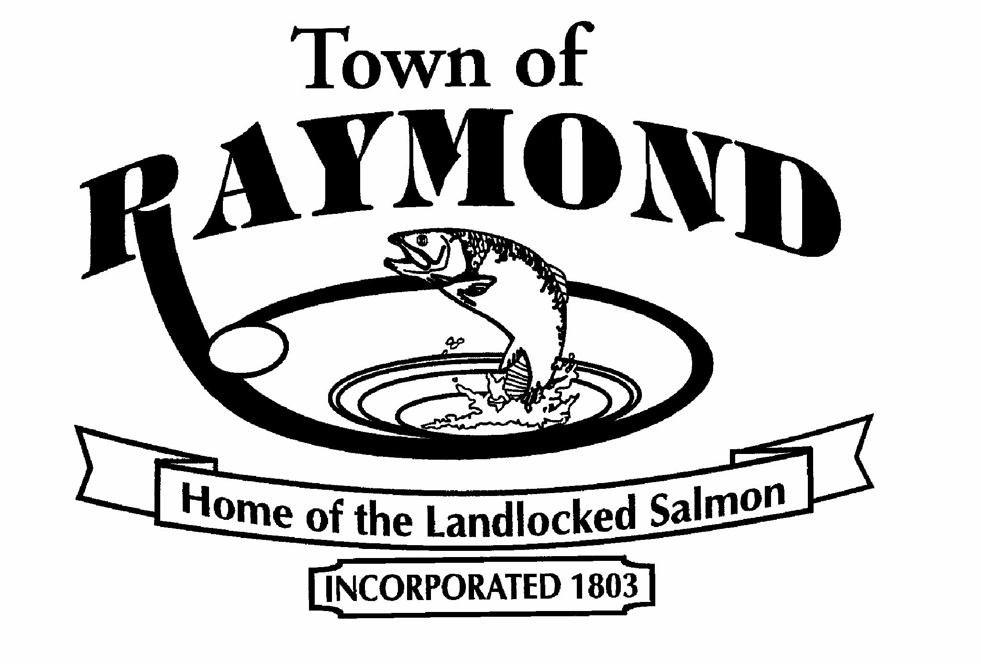

TOWN OF RAYMOND, MAINE

Full-Time Public Works Position

The Town of Raymond is seeking one full-time laborer/truck driver to join our Public Works Department. Successful applicants must have a valid CDL license (class A or B) with a clean driving record and experience in the operation of heavy equipment and all aspects of municipal Public Works functions. The work week consists of ten-hour days Monday through Thursday.

The Town of Raymond offers competitive pay and benefits including medical and dental insurance, life insurance and a 457 deferred compensation plan.

Applications are available on the website at www.raymondmaine.org or at the Raymond Town Office. Completed application, cover letter and resume can be emailed to cathy.gosselin@raymondmaine.org, or mail to the Town Office:

Cathy Gosselin
Human Resource Officer
401 Webbs Mills Road
Raymond, ME 04071
207-655-4742 X 123

Position open until filled.
The Town of Raymond is an Equal Opportunity Employer.

